**CHAPTER 1**

**INTRODUCTION**

**1.1 PROJECT AIM:**

The main conceptual idea of the **Clinic Nallam Management System** designed to control the patients, manage appointments, financial reports, asset status, blood donors and manage staff. The **Clinic Nallam Management System** goal is to reduce the time and resources currently required for such tasks.

## **1.2.PROCEDURE:**

## The procedure mainly includes the development of a dynamic web application wherein the patients have to register themselves then login and thereafter they can take appointments can update their profile and for the doctor module also they have to login and then they can update their profile and watch the scheduled appointments. The use of MySQL database helps the Hospital as well as the individual doctors to keep track of their appointments’ data. With the help of this application, the users/patients who wants to donate blood can register themselves such that whenever emergency comes blood will be required, then those persons will be called for the blood transfusion. The registration of the doctors are not done outside it is done in the admin module where admin can add specialization and also add new doctors. The admin can manage patients and also watch the scheduled appointments.

**1.3.PROJECT DESCRIPTION:**

The main function of the system is to take appointments with the doctor, register blood donors, patient details, doctor details, financial reports, asset status, vehicles details, manage staff and retrieve these details as and when required, and also to manipulate these details meaningfully. System input contains equipment details, doctor appointment, patient details, doctor details, vehicle details, assets while system output is to get these details on to the screen. The Clinic Nallam Management System can be entered using their respective username and password. The data are well protected for personal use and makes the data processing very fast.

* 1. **PLAN OF THE REPORT**

**This report contains a detailed discussion about the project undertaken and completed. The different phase involved in completed of this project has been explained explicitly and in a sequence.**

**Till now, in chapter 1 an introduction has been given which contains information about project containing information about the application developed.**

**Secondly, in chapter 2 the topic that has been discussed is “Problem definition and feasibility analysis”. This part deals with the problem definition and how feasible the developed application is in terms of technique, operation and time. Both of the important aspects has been covered in this second chapter.**

**Then, there comes requirements that are to be discussed later. Third chapter deals with Software Requirements Specification which includes information about various requirements for this application so developed. Mostly, it includes the details of the hardware requirements and software requirements.**

**Chapter 4 deals with the System Analysis.**

**Chapter 5 deals with System Design which includes information about the application design. It also includes the usage of Use-Case diagrams and Class diagrams and many more UML diagrams to give a better understanding about the project.**

**Chapter 6 deals with System Implementation and Testing. As the name suggests it contains the details about the technologies used for implementing the application as well as different testing criterions.**

**Chapter 7 contains the Conclusion and Foreseeable Enhancements which covers the future enhancements which can be done to make the application look better.**

**CHAPTER 2**

**PROBLEM DEFINITION AND FEASIBILITY ANALYSIS**

**2.1. PROBLEM DEFINITION**

**The “Clinic Nallam Management System” has been developed to override the problems prevailing in the practicing manual system. This software is supposed to eliminate and in some cases reduce the hardships faced by this existing system. Moreover this system is designed to make it online to carry out operations in a smooth and effective manner.**

**The application is reduced as much as possible to avoid errors while entering data. It also provides error messages while entering invalid data. No formal knowledge is needing for the user to use this system. Thus it proves that the application designed is user-friendly.** In prior days managing patient details, a schedule appointment was entirely based on manual effort and it is time consuming process. The**Clinic Nallam Management System** has been proposed to overcome such problems. This emphasizes a continuous and comprehensive upgrading of visualizing the required changes in the modernized technology.

Generally, the purpose of this project is to provide complete and up-to-date online scheduled appointments for current doctor members in Clinic Nallam.

Specifically, it aims to maintain records on:   
a. Patient Profile  
b. Appointment history  
c. Doctor Profile  
d. Scheduled appointments  
e. Manage Doctor  
f. Manage Patients

g. Total Scheduled appointments

h. Financial reports

i. Asset Status

j. Manage staff

k. Patient Session

l. Doctor Session

**2.1.1. ADVANTAGES OF THE PROPOSED SYSTEMS**

* **Patients just need to log in and then they can update profile, take appointment with specialized doctor and watch his/her appointment history.**
* Doctors just need to log in and then they can update profile, watch the scheduled appointments.
* Management of the doctors and patients is done in the admin module.
* Admin can add specialization, doctors and watch the scheduled appointments.
* **The users/patients can voluntarily register themselves for blood donation, as when emergency occurs they can be contacted for blood donation.**
* **Watch Financial reports regarding income and expense.**
* **Add details of the assets and watch it’s status.**
* **Manage all the staffs of the clinic.**

**2.2. FEASIBILITY ANALYSIS**

**Feasibility analysis** is the process of confirming that a strategy, plan or design is possible and makes sense. This can be used to validate [assumptions](https://simplicable.com/new/project-assumptions), [constraints](https://simplicable.com/new/business-constraints), [decisions](https://simplicable.com/new/decision-making-techniques), approaches and [business cases](https://simplicable.com/new/business-case). **This section depicts the most important stages of the initial investigation carried out as part of the life cycle of the project which can face certain shortcomings.**

A feasibility study tests the viability of an idea, a project or even a new business. The goal of a feasibility study is to emphasize potential problems that could occur if one pursues a project and determine if, after considering all significant factors, the project is a good idea. Feasibility studies also allow a business to address where and how it will operate, potential obstacles, competition and the funding needed to get the business up and running.

Therefore during the feasible study of our project, we have considered the following fields:-

* Technical Feasibility
* Economical Feasibility
* Operational Feasibility
* Schedule Feasibility

**2.2.1. TECHNICAL FEASIBILITY**

Technical feasibility includes existing and new Hardware and Software requirements that are required to operate the project. The basic software requirements in which the backend as well as the frontend of the project Clinic Nallam Management System has been developed. The architectural configuration of my computer is:

* Processor AMD A4-3305M 1.9 GHz
* Hard Disk 500gb
* RAM 4GB
* Monitor 15(inch)

**2.2.2. ECONOMICAL FEASIBILITY**

An evaluation for the development cost was weighed against the ultimate income of benefit derived from the development process of the project. In economic feasibility, cost benefit analysis is done in which expected cost and benefits are evaluated.

Economic justification includes a broad range of concerns that include cost benefit analysis. In this we weigh the costs and benefits associated with the candidate system and if it suits the basic purpose of any organization i.e. profit making, the project is sent to the analysis and design phase.

The Clinic Nallam Management System does not require enormous amount of money to be developed. This can be done economically if planned judicially, so it is economically feasible. The cost of the project depends upon the number of man-hour required.

**2.2.3. OPERATIONAL FEASIBILITY**

It is mainly related to human organizations and political aspects. The points to be considered are:

* The changes that will be brought about with the incorporation of this project with the existing system.
* The organization structures that might be disturbed.

The system is operationally feasible as it is very easy for the end users to operate with it. It only needs basic information about Windows platform.

**2.2.4. SCHEDULE FEASIBILITY**

Time evaluation is the most important consideration in the development of the project. The time schedule required for the development of this project is very important since more development time effect machine time, cost and cause delay in the development of other systems. A reliable Clinic Nallam Management Systemcan be developed in considerable amount of time.

**2.3 RECOMMENDED IMPLEMENTATION**

From the above observation made in the feasibility study described above, it was recommended that the proposed “Clinic Nallam Management System” is feasible for its development and implementation.

**CHAPTER 3**

**SOFTWARE REQUIREMENTS SPECIFICATION**

**3.1. PROJECT MODULE:**

Since **Clinic Nallam Management System is a joint project of two members, following are the modules undertaken by me:**

* Patient Module
* Doctors Module
* Donate Blood
* Manage Patients
* Manage Doctors
* Manage Appointment

**PATIENT MODULE:**

Here in this module the registered users/patients can login to else they have to register first then they can login to the module. Inside this module patients can update their account , take appointment, watch their appointment history and can change their password.

**DOCTOR MODULE:**

In this module doctor can login to his/her account and then they can update their profiles also they can watch the scheduled appointments.

**DONATE BLOOD:**

Here the patients or the users whoever wants to donate blood can register.

**MANAGE PATIENTS:**

This is present inside Admin module where the admin can manage the patients.

**MANAGE DOCTORS:**

This is also present inside the Admin module where the doctors can be managed i.e., add doctors, add specialization.

**MANAGE APPOINTMENT:**

Now here the admin can manage the appointments scheduled for the doctors.

* 1. **SOFTWARES REQUIREMENTS**
* **XAMPP (FOR ALL OPERATING SYSTEMS: WINDOWS, MAC OS AND LINUX):**

XAMPP is a free and open-source cross-platform web server solution stack package developed by Apache Friends, consisting mainly of the Apache HTTP Server, MariaDB database, and interpreters for scripts written in the PHP and Perl programming languages.

* **NOTEPAD++:**

Notepad++ is a text editor and source code editor for use with Microsoft Windows. It supports tabbed editing, which allows working with multiple open files in a single window. The project's name comes from the C increment operator. Notepad++ is distributed as free software.

* **GOOGLE CHROME(OR ANY OTHER WEB BROWSERS):**

Google Chrome is a freeware web browser developed by Google LLC. It was first released on September 2, 2008 for Microsoft Windows, and was later ported to Linux, macOS, iOS and Android. Google Chrome is also the main component of Chrome OS, where it serves as a platform for running web apps.

**3.3. MINIMUM HARDWARE REQUIREMENTS:**

RAM **:** 1 GB

HARD DISK **:** 80 GB

WINDOWS **:** Windows 7

INPUT **:** Keyboard, Optical mouse or Touch pad

MONITOR **:** 800x 600, 256 colors.

|  |  |  |
| --- | --- | --- |
|  |  |  |
|  |  |  |
|  |  |  |
|  |  |  |

**CHAPTER 4**

**SYSTEM ANALYSIS**

**4.1 EXISTING SYSTEM:**

Hospitals currently use a manual system for the management and maintenance of critical information. The current system requires numerous paper forms, with data stores spread throughout the hospital management infrastructure. Often information is incomplete or does not follow management standards. Forms are often lost in transit between departments requiring a comprehensive auditing process to ensure that no vital information is lost. Multiple copies of the same information exist in the hospital and may lead to inconsistencies in data in various data stores.

**4.2 PROPOSED SYSTEM:**

The Clinic Nallam Management System is designed to replace their existing manual paper based system. The new system is to control the information of patients, financial reports, asset status, vehicles, managestaff and also the scheduled appointments. These services are to be provided in an efficient, cost effective manner, with the goal of reducing the time and resources currently required for such tasks.

Maintenance of records is important. They can help the administration spot recurring problems and ensure that work meets the management guidelines.

* Our application is dynamic
* The patients can register, take appointment and watch appointments history.
* The doctors can log in and watch the scheduled appointments.
* The blood donors can register themselves for donating blood.
* Watch the financial reports, assets status, vehicles details and blood bank.
* Manage Staffs and any type of queries from the users.

For the DBMS, the following tables have been prepared:

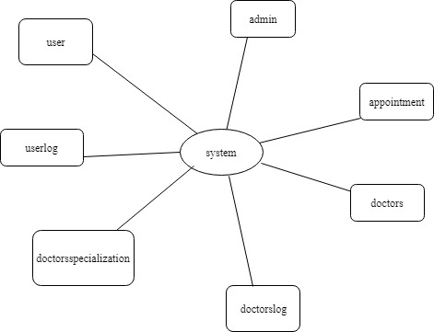

Figure of User’s database

**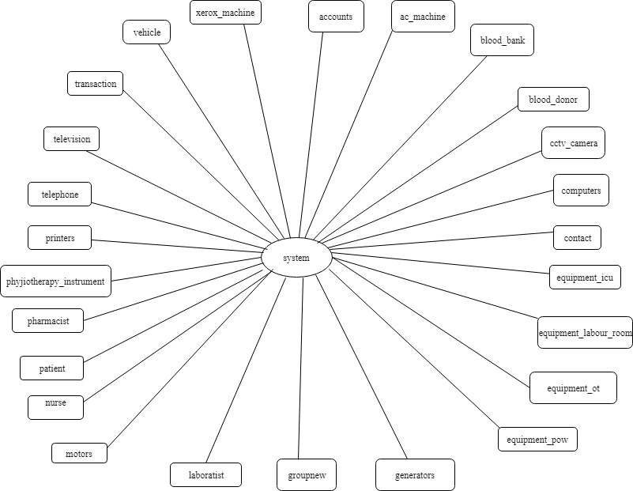**

Figure of Hospital components database

**CHAPTER 5**

**SYSTEM DESIGN**

**5.1.INTRODUCTION**

The design document that we will develop during this phase is the blueprint of the software. It describes how the solution to the prevailing problem is to be built. Since solution to complex problems isn’t usually found in the first try, iterations are most likely required. This is true for software design as well. For this reason, any design strategy, design method, or design language must be flexible and must easily accommodate changes due to iterations in the design. Any technique or design needs to support and guide the portioning process in such a way that the resulting sub problems are as independent as possible from each other and can be combined easily for the solution to the overall problem. Sub-problem independence and easy combination of their solutions reduces the complexity of the problem.

**5.2. USE CASE DIAGRAM:**

A use case diagram is a graphic depiction of the interactions among the elements of a system. A use case is a methodology used in system analysis to identify, clarify, and organize system requirements. A use case diagram at its simplest is a representation of a user's interaction with the system that shows the relationship between the user and the different use cases in which the user is involved.

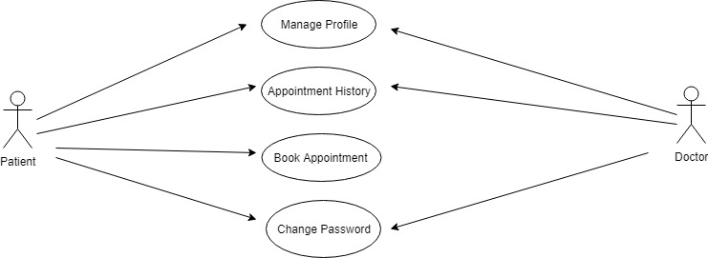

Figure 1 shows the use of the Patient and Doctor Module

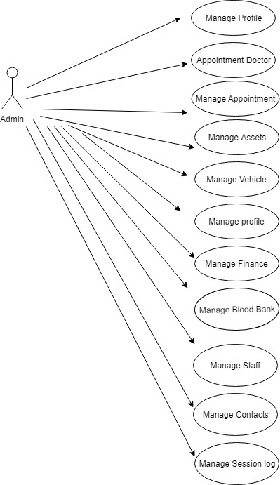

Figure 2 shows the use of the Admin Module

**5.3. CLASS DIAGRAM**

A class diagram in the Unified Modeling Language (UML) is a type of static structure diagram that describes the structure of a system by showing the system’s classes, their attributes, operations (or methods), and the relationships among objects.

Class diagrams are one of the most useful types of diagrams in UML as they clearly map out the structure of a particular system by modeling its classes, attributes, operations, and relationships between objects.

The class shape itself consists of a rectangle with three rows. The top row contains the name of the class, the middle row contains the attributes of the class, and the bottom section expresses the methods or operations that the class may use. Classes and subclasses are grouped together to show the static relationship between each object.

The purpose of the class diagram can be summarized as Analysis and Design of the static view of an application.

**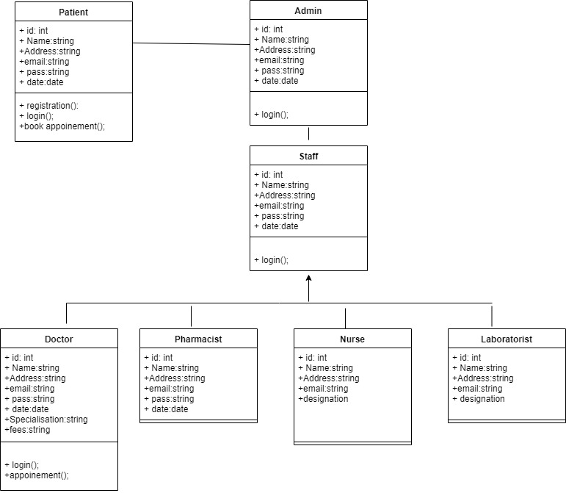**

Figure 3 shows the Class Diagram

**5.4. ACTIVITY DIAGRAM**

Activity diagram is another important diagram in UML to describe the dynamic aspects of the system. Activity diagram is basically a flowchart to represent the flow from one activity to another activity. The activity can be described as an operation of the system. The control flow is drawn from one operation to another.

Activity diagrams are graphical representations of [workflows](https://en.wikipedia.org/wiki/Workflow) of stepwise activities and actions with support for choice, iteration and concurrency. In the [Unified Modeling Language](https://en.wikipedia.org/wiki/Unified_Modeling_Language), activity diagrams are intended to model both computational and organizational processes (i.e., workflows), as well as the data flows intersecting with the related activities. Although activity diagrams primarily show the overall flow of control, they can also include elements showing the flow of data between activities through one or more data stores.

**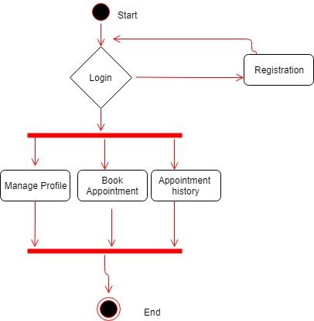**

Figure 4 shows the use of Activity Diagram for Patient

**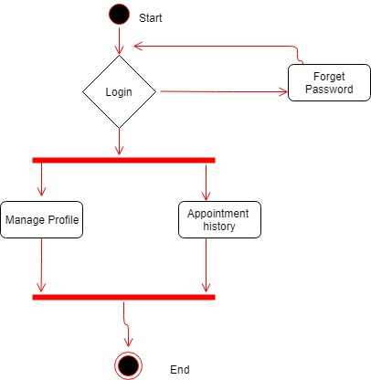**

Figure 5 shows the use of Activity Diagram for Doctor

**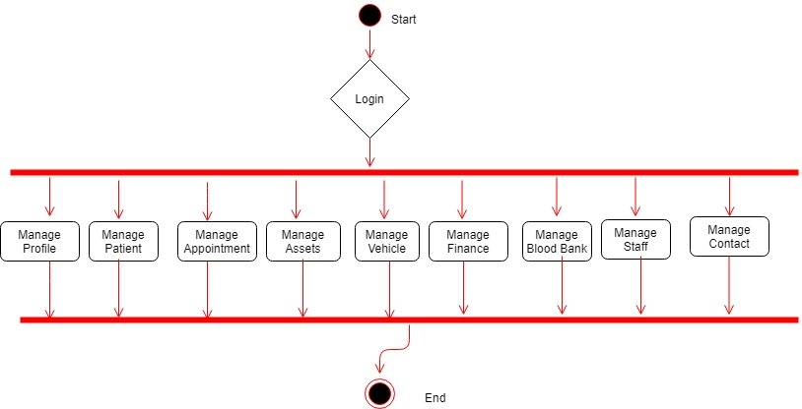**

Figure 6 shows the use of Activity Diagram for Admin

**5.5. SEQUENCE DIAGRAM**

Sequence diagrams are sometimes called event diagrams or event scenarios. A sequence diagram shows, as parallel vertical lines (lifelines), different processes or objects that live simultaneously, and, as horizontal arrows, the messages exchanged between them, in the order in which they occur.

**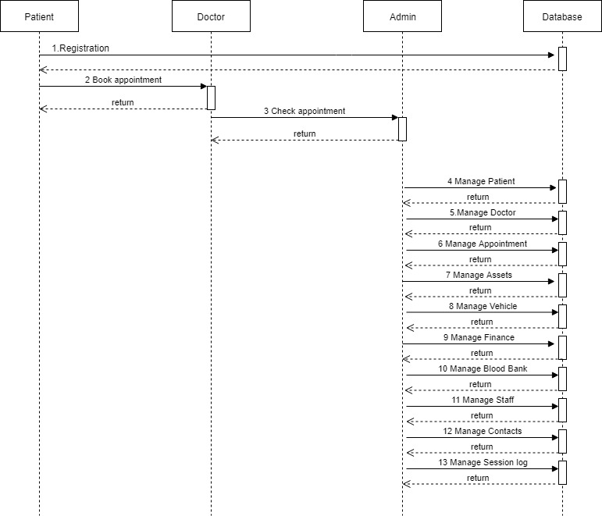**

Figure 7 shows the use of Sequence Diagram

**5.6. DEPLOYMENT DIAGRAM**

Deployment diagram is a structure diagram which shows architecture of the system as deployment (distribution) of software artifacts to deployment targets. Artifacts represent concrete elements in the physical world that are the result of a development process.

**Hospital Local Server**

**desktop Client**

**Printer**

**Database Server**

Figure 8 shows the use of Deployment Diagram

**CHAPTER 6**

**TESTING AND IMPLEMENTATION**

**6.1. SYSTEM IMPLEMENTATION DETAILS**

The application Clinic Nallam Management System which has been successfully implemented is a web application or internet based application which has its output displayed in a browser. The browser can be any web browser such as Chrome, Mozilla Firefox, and Chromium etc...

Since an application to be developed has to have a lot of aspects such as technology used for designing, framework, web technology, code behind etc., even this application has been done in different technologies for different aspects.

Any application would not be complete if the designing is not complete since the success of the webpage depends on the appeal of the webpage to the users which is an important fact. The application Clinic Nallam Management System uses HTML, CSS, Bootstrap, Jquery and JavaScript for design purposes.

The web technology and the code behind used in this application is PHP. What distinguishes PHP from something like client-side JavaScript is that the code is executed on the server, generating HTML which is then sent to the client. The client would receive the results of running that script, but would not know what the underlying code was. You can even configure your web server to process all your HTML files with PHP, and then there's really no way that users can tell what you have up your sleeve.

The best things in using PHP are that it is extremely simple for a newcomer, but offers many advanced features for a professional programmer. Don't be afraid reading the long list of PHP's features. You can jump in, in a short time, and start writing simple scripts in a few hours.

Every application developed needs to have a technology to handle the data to be used in it. The information can be small or can be very large occupying large amounts of space. The database technology used in this application is MYSQL.

**6.2. TESTING**

The process of testing of an integrated hardware and software system to verify that the system meets its specified requirements.

### ****6.2.1 PERFORMING SYSTEM TEST:****

It is basically a part of software testing and test plan should always contain specific space for this testing.

To test the system as a whole, requirements and expectations should be clear and the tester needs to understand the real-time usage of application too.

Also, most used third-party tools, version of OSes, flavors and architecture of OSes can affect system’s functionality, performance, security, recoverability or install ability.

Therefore, while testing system a clear picture of how the application is going to be used and what kind of issues it can face in real time can be helpful. In addition to that, a requirements document is as important as understanding the application.

Clear and updated requirements document can save tester from a number of misunderstandings, assumptions and questions.

In short, a pointed and crisp requirement document with latest updates along with an understanding of real-time application usage can make ST more fruitful.

This testing is done in a planned and systematic manner.

**Given below are the various steps involved while performing this testing:**

* The very first step is to create a Test Plan.
* Create System Test Cases and test scripts.
* Prepare the test data required for this testing.
* Execute the system test cases and script.
* Report the bugs. Re-testing the bugs once fixed.
* [Regression testing](https://www.softwaretestinghelp.com/regression-testing-tools-and-methods/) to verify the impact of the change in the code.
* Repetition of testing cycle till the system is ready to be deployed.
* Sign off from the testing team.

[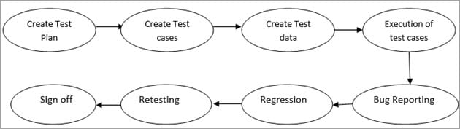](https://cdn.softwaretestinghelp.com/wp-content/qa/uploads/2018/05/Steps-to-perform-System-Testing.jpg)

**6.2.2. THINGS TO TEST**:

**The points stated below are covered in this testing:**

* [End to end testing](https://www.softwaretestinghelp.com/what-is-end-to-end-testing/) which includes verifying the interaction between all the components and along with the external peripherals to ensure if the system works fine in any of the scenarios is covered in this testing.
* It verifies that the input provided to the system provides the expected result.
* It verifies if all the functional & non–functional requirements are tested and if they work as expected or not.
* [Ad-hoc](https://www.softwaretestinghelp.com/ad-hoc-testing/) and exploratory testing can be performed in this testing after scripted testing has been completed. [Exploratory testing](https://www.softwaretestinghelp.com/what-is-exploratory-testing/) and ad-hoc testing helps to unfold the bugs which cannot be found in scripted testing as it gives freedom to the testers to test as their desire is based on their experience and intuition.

### 6.2.3. ADVANTAGES

There are several advantages.

* This testing includes end to end scenarios to test the system.
* This testing is done in the same environment as of the Production environment which helps to understand the user perspective and prevents the issues which can occur when the system goes live.
* If this testing is done in a systematic and proper manner, then it would help in mitigating the post-production issues.
* This testing tests both the application architecture and the business requirement.

**6.3. Debugging**

Debugging occurs as a consequence of successful testing. That means when a test case uncovers an error, debugging is an orderly process that is carried out for the removal of that error.

The debugging process will always have one of the two outcomes:

* 1. The cause will be found, corrected and removed.
  2. The cause will not be found.

Thus it can be concluded that the Clinic Nallam Management System was tested and successfully debugged and rendered error-free.

**CHAPTER 7**

**CONCLUSION AND FORESEEABLE ENHANCEMENTS**

From the outcome of this project, we hope that this application provided us development in both personal and professional aspects.

This project enhanced our knowledge and also provided significant experience for designing projects specifically in data base management system (DBMS) which can be later used in our respective employment organizations.

Personally, this project provided us the knowledge and experience that we can share to our fellow students and other people who may need our assistance in the future.

**FORESEEABLE ENHANCEMENTS**

Enhancements in different fields of this application can be made. This application was completed in a predefined time but if some more could be devoted to it could have worked out better.

**SCREENSHOTS**

Following are the screenshots of the database and the tables that have been created for this application using MySQL in XAMPP:-

* Database 1

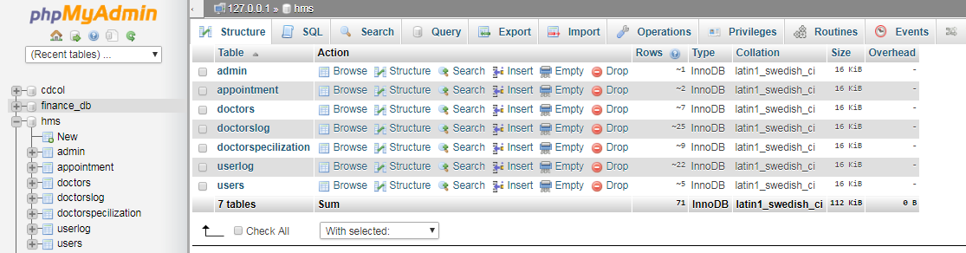

* Database 2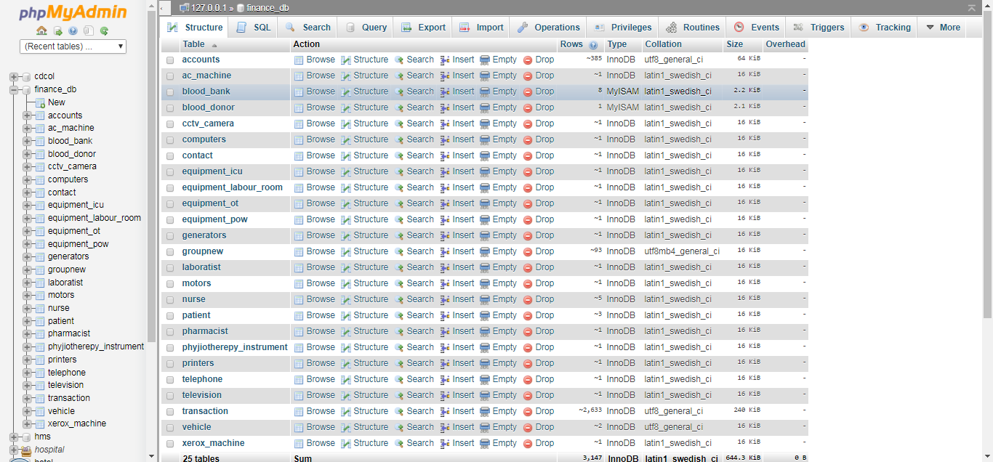

Screenshots of Homepage:

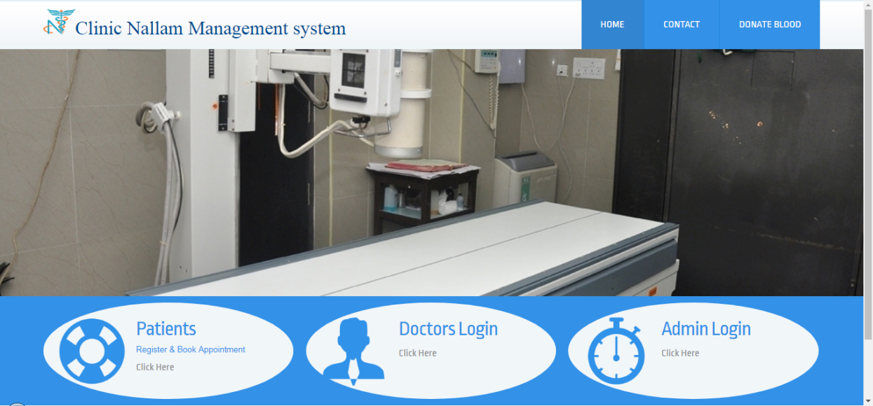

Contact us :

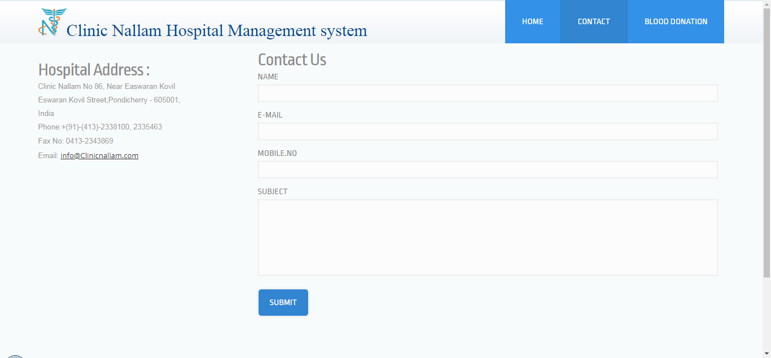

Blood Donation Registration:

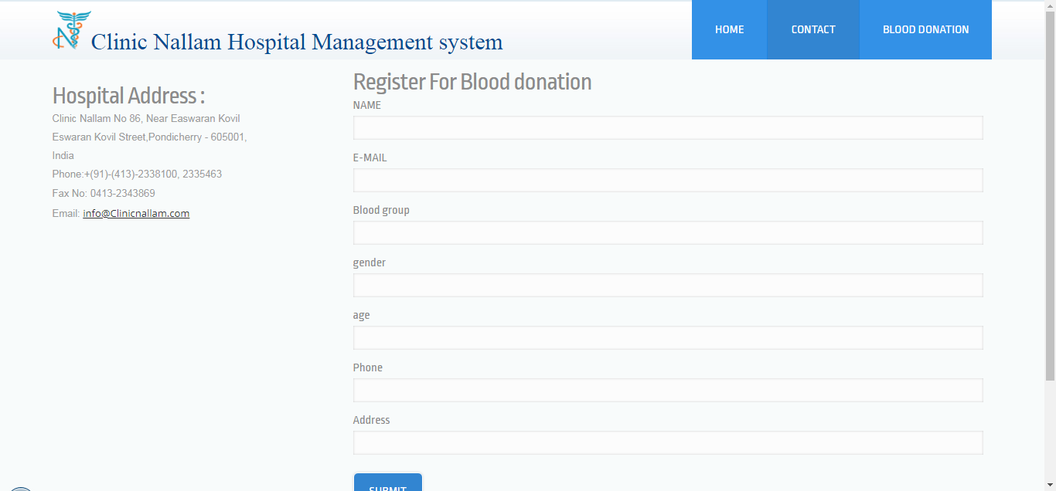

Patient Log in Screen:

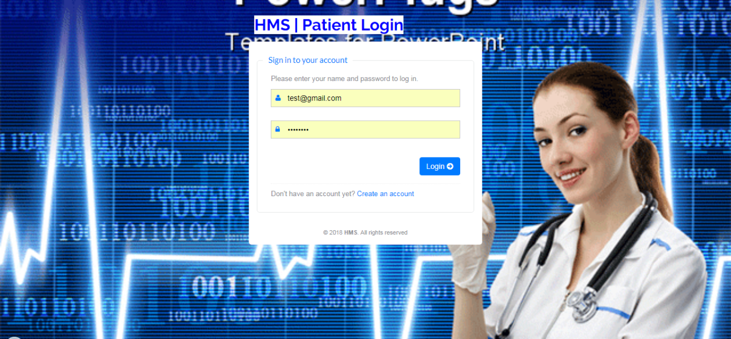

Patient Dashboard:

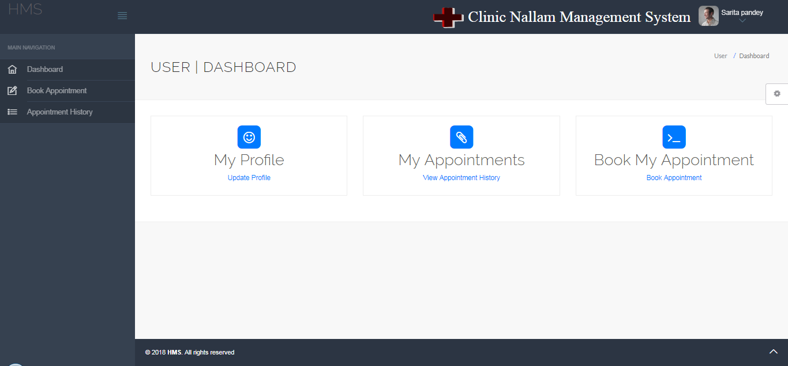

Patient Update Profile:

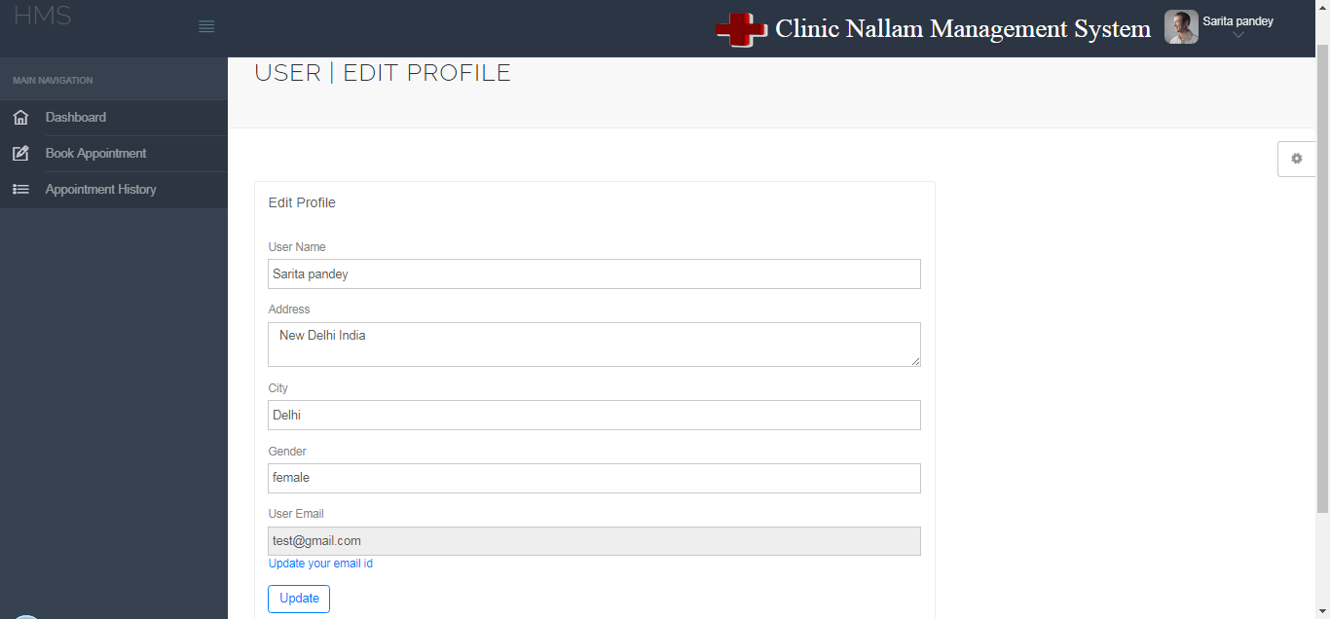

Patient Taking Appointment:

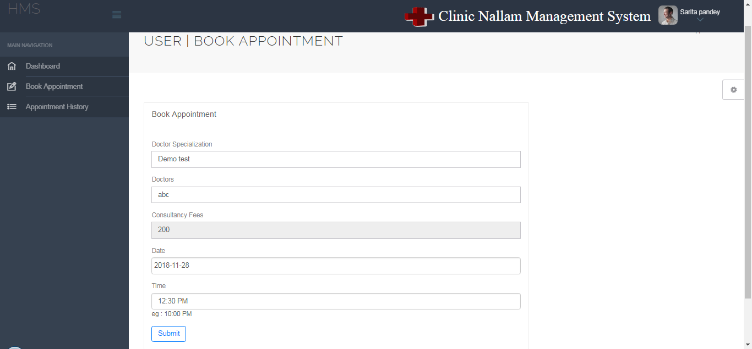

Patient Appointment History:

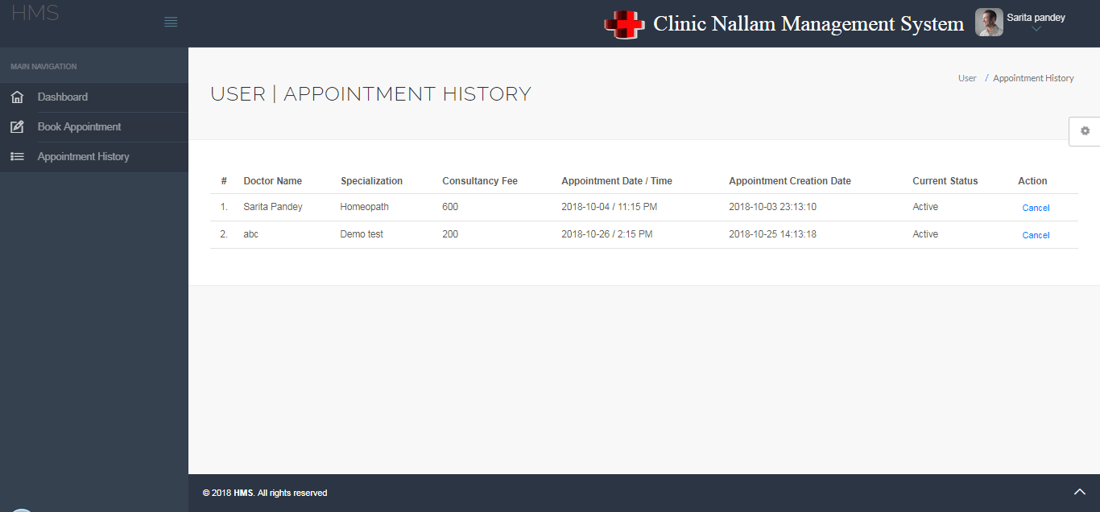

Doctors Dashboard:

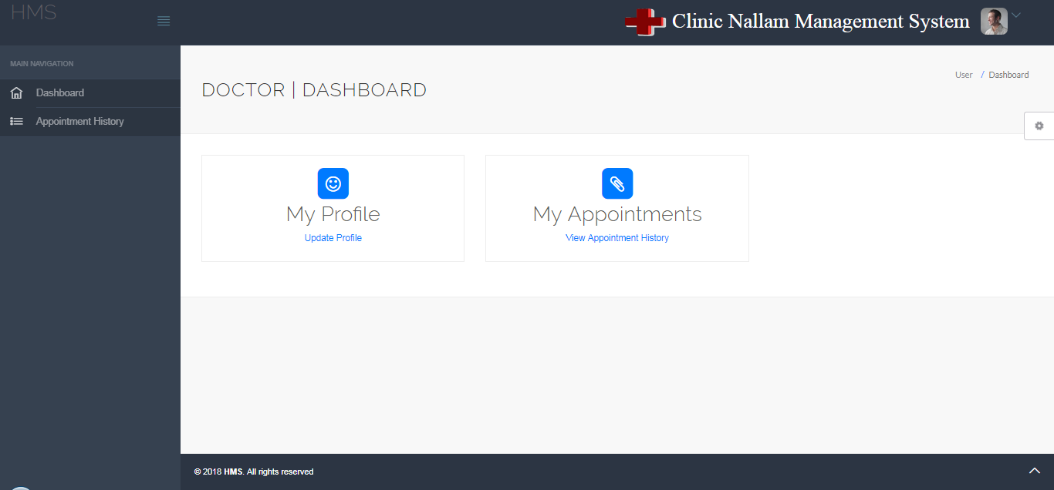

Doctor Update Profile:

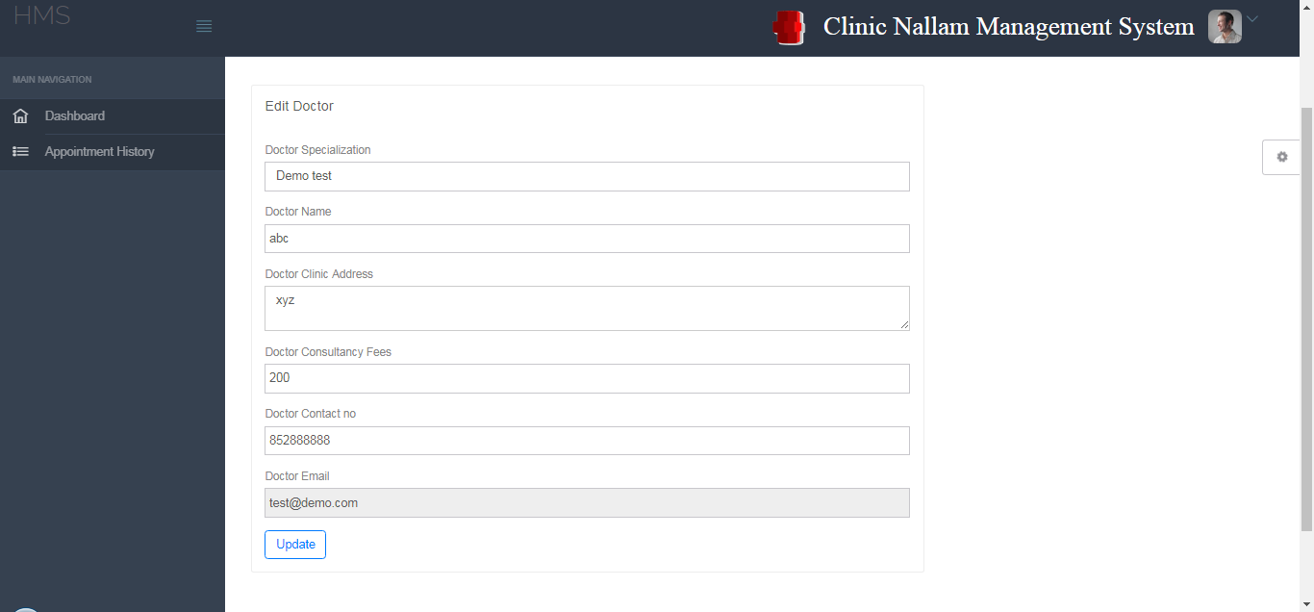

Doctor Appointment History:

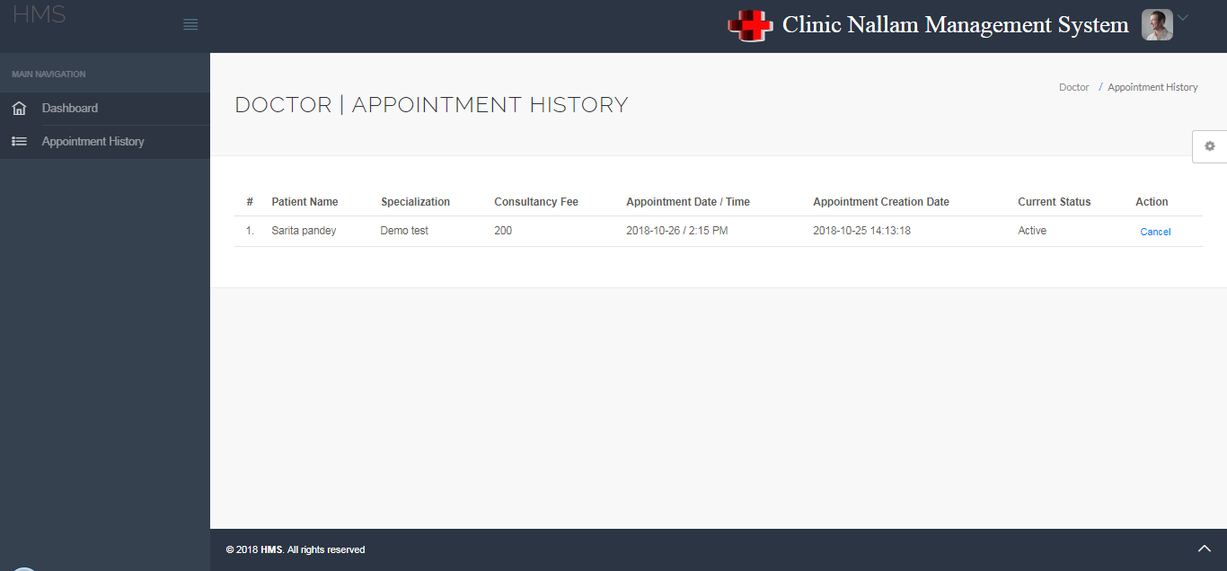

Add Doctor Specialization:

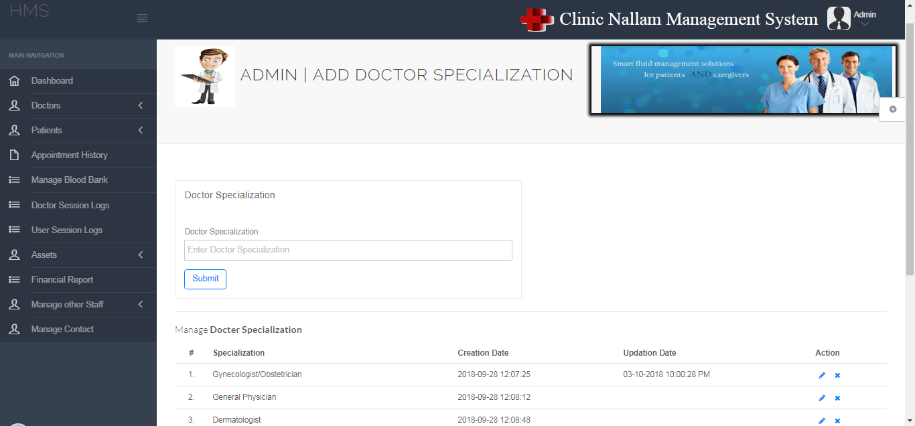

Add Doctor:

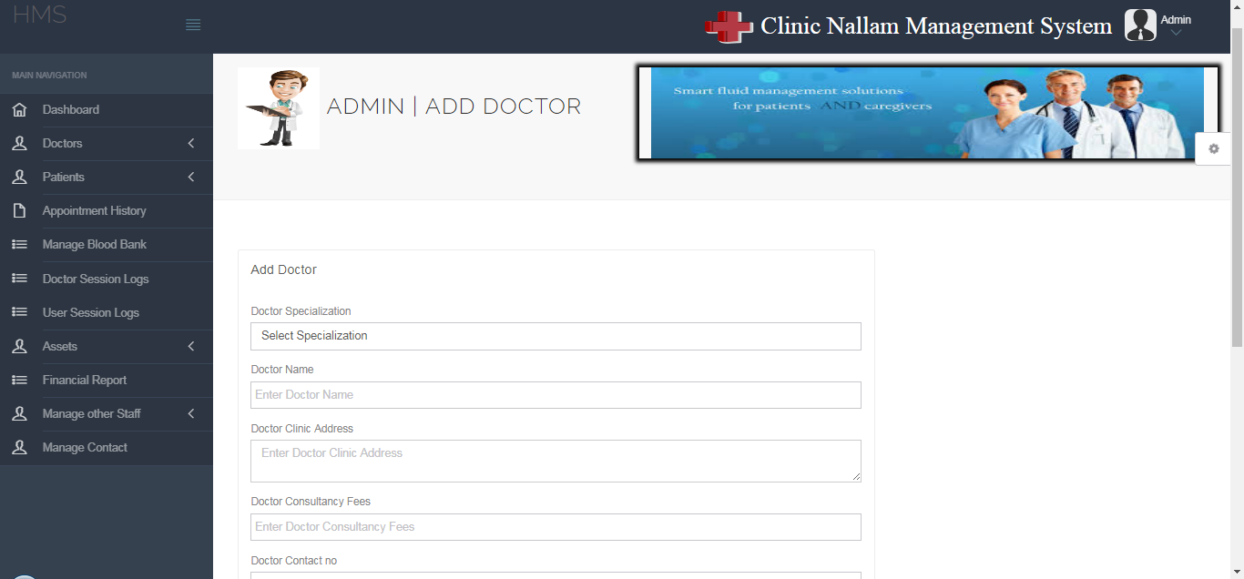

Manage Doctors:

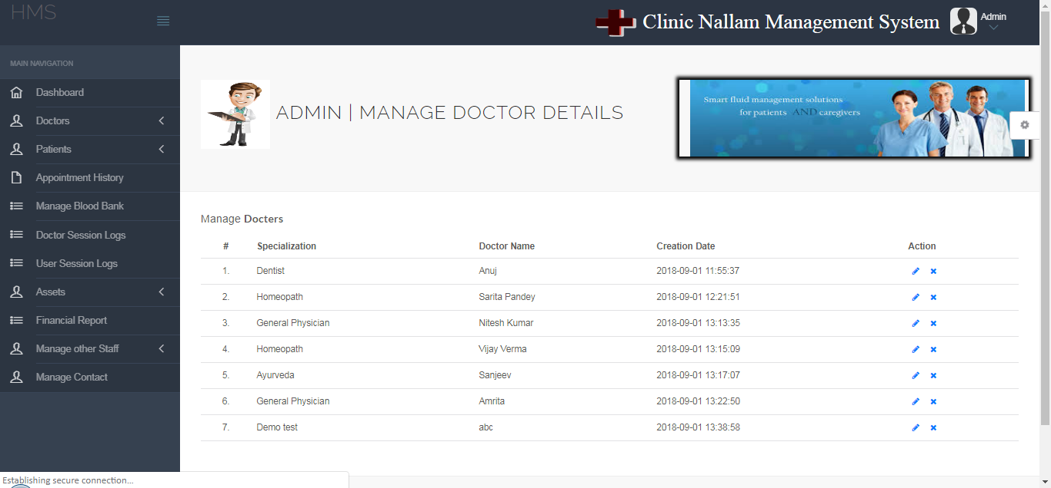

Manage Patients:

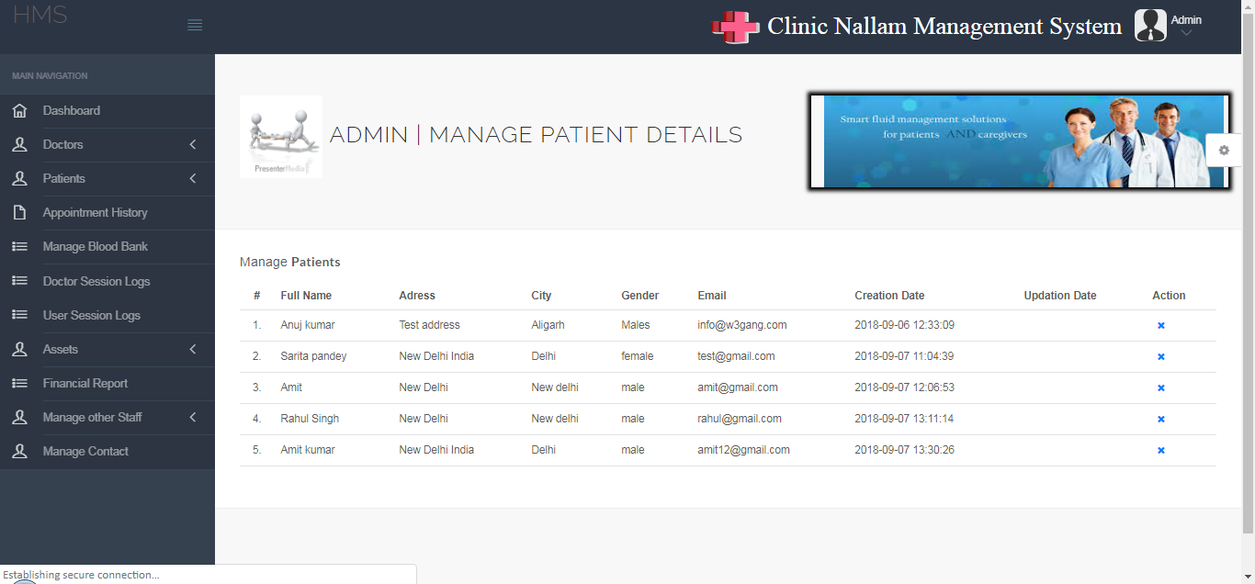

Patient Appointment History:

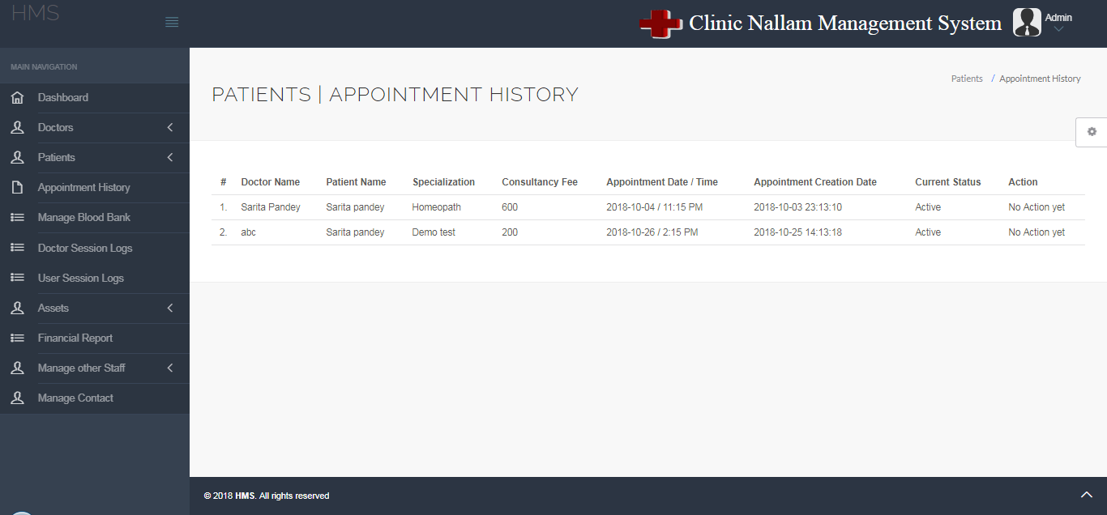

**REFERENCES**

For the successful implementation of the project Clinic Nallam Management Systemthe following resources have been used:

* <https://stackoverflow.com/>
* <https://www.w3schools.com/>
* <http://php.net/manual/en/intro-whatis.php>
* [https://www.mysql.com/](https://www.mysql.com/" \t "_blank)
* <https://www.youtube.com/>
* [https://jsfiddle.net/](https://jsfiddle.net/" \t "_blank)